Needs Assessment: Joshua Tree Soccer Program

Rachel Griffith and Adriene-Noele Moore

California State San Bernardino

It is no surprise that sports can play a vital role in a child’s life. They provide basic social skills and teach the importance of teamwork from a very young age. Not only this, but “engaging in regular physical activity has long been associated with positive health outcomes including prevention… of obesity” (Kristjansson et al., 2015). The Joshua Tree Youth Soccer Program is one of the many places that provide these essential lessons for children in their own community. The purpose of this needs assessment is to determine the discrepancies in the Joshua Tree Youth Soccer Program in order to determine what can be done to make it a more successful program. The goal is to provide realistic recommendations that can be implemented by the recreation department with minimal additional financial responsibility. Departments such as the Joshua Tree Youth Soccer Program rely almost entirely on community involvement. Without this, there are no kids to participate and no volunteers to help run the program. Joshua Tree is a relatively small city and programs like this one are important to help build community camaraderie.
Participants
The stakeholders and participants included the head of youth sports at the recreation center and the parent volunteers/coaches. These participants offered valuable information concerning the current performance gaps in the current system. The sample group was smaller than ideal, but they did offer fairly consistent information that provided enough data to analyze. It was extremely difficult to set up times to get interviews, so many of the interview participants were sent a set of questions; then, if further information was needed a follow up was done. The interviews consisted of 50% parent coaches and 50% parents. The questionnaire was sent out to all the parents of participants from this season and 12 responses were received. All the participants answered the open ended questions in a very relevant manner. The parent participants all had been with the soccer program for at least 1 season. Most of the parents did not volunteer beyond bringing snacks. Those who did volunteer volunteered for large positions such as coaching seasons.
Data Collection
Three tools were used to collect data: observation, questionnaire and interviews. The observations were done on teams consisting of multiple age groups during the active Joshua Tree soccer season, during practices and games. This method was chosen in order to see the program in action and collect qualitative data. Multiple elements of the program were taken into consideration while observing: coaches, volunteers, equipment, flow of the practices and games, referees, coaches interaction,
and control of the children. These guidelines helped stay on task and pay particular attention to specific elements of the program.
The second tool that was used was a questionnaire that was delivered via email. Suggestions from Radhakrishna’s article “Tips for developing and testing questionnaires/instruments” (2007) were used to ensure sufficiency of the questions and format. The program director dispersed the questionnaire using the email list from the most recent soccer season. The questions were constructed using data collected from observation and experience. The goal of the questionnaire was to collect a significant amount of quantitative data from as many experienced parents/guardians as possible. The questions covered general information, as well as specific information concerning the instruction their children received, the organization of the the program, and other important elements. The format was set up in a way that the questions became more developed as the participants got further along. Each question was required to answer in order to move to the next, preventing participants from skipping questions.
Thirdly, interviews were done with the program director and 6 parents/coaches (Appendices C & D). The interview questions were also constructed using data collected through observation and experience. This tool was created in order to collect more quality information that cannot be collected via questionnaire. The participants that were willing to take part in the interview portion were mostly parents that coached their children’s team, including two sets of married parents who each coached one of their children’s teams.
Data Analysis
The data was analyzed descriptively. The goal was to have a larger number of parents participate in the questionnaire; however, not all the parents filled it out. Although the number of participants was not overwhelming, the answers were consistent and informative, giving a fair amount of data.
This needs assessment, according to the data, concludes that there are multiple gaps that needs to be dealt with. Organization is the most common problem that has been found when analyzing the data collected from the parent interview. Much of the
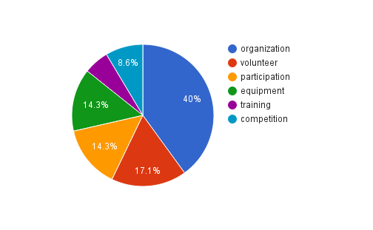

comments provided during the interviews fell under organizational gaps.
Next, the department head was interviewed (Appendix C). The department head had an extensive knowledge of working with community sports and had over 10 years of experience. She was also sent a set of questions via email. The department head surprisingly identified less gaps than the parent volunteers. From the pie chart above, it is clear that parents found that organization was the biggest problem or gap in the department. According to the department head, organization was just one small portion of the gaps she identified. In her answers, she mention community involvement and noted that it seemed the parents were satisfied to very satisfied with the department as a whole. She mentioned a reason for the lack of community involvement possible being because they run their program in-house versus using a more well known contract organization. The only mention of money being a factor in being a possible reason for how the program would run more smoothly was when the department head mention that they did not possess the required funding for the training needed.
The department is fairly small with only 2 employees that actually work with the soccer teams. When they aren't available, other employees, like part time preschool staff, will fill in and support at games. The department head did feel that bi monthly training sessions with her employees would be beneficial and would decrease some of the organizational issues. There also seemed to be no connection between success of the team and the department’s organization.
The questionnaire for the parents showed that most families came in contact with the soccer program in person at the department offices versus on flyers or by word of mouth. Most of the children missed 1-2 practices and the parents didn’t feel that affected their child’s playing time. Only 2 parents felt that their child did not improve their soccer skills while playing in the program and the rest felt that their children did benefit. The majority of the parents also noted that their child gained important social and teamwork skills. The only complaint to take away from the interviews once again had to do with organization in general. Some parents said the field was not ready to be played on since it was all dirt and filled with thorns, and they did not receive their uniforms until well into the season. Another problem parents identified was that there weren’t enough games in the season. When answering the question regarding volunteering, most parents stated that either they didn’t have the time or they did have knowledge of the game of soccer, or both.
The data ultimately revealed several performance gaps in the department. With these gaps being identified, we are able to create sufficient recommendations to the department head and volunteers involved in the soccer program.
Conclusion
It has been concluded that parents are generally satisfied with the Joshua Tree Soccer program. According to the questionnaire, based on a Likert scale, the mean on the satisfactory rating was 4.3 and the mode was 5. Although, there was a high value placed on satisfaction, parents still expressed valid concerns about the problems that occurred during the past season. Parents also expressed satisfaction with their children’s teamwork and soccer skills, as shown in the graphs below.
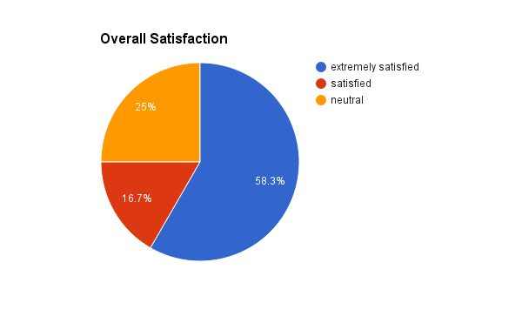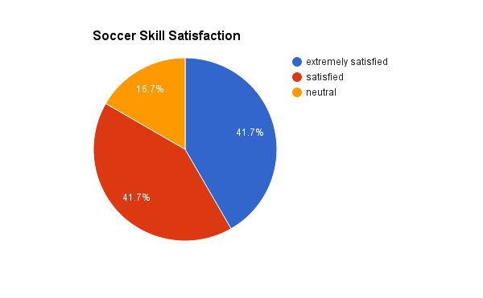
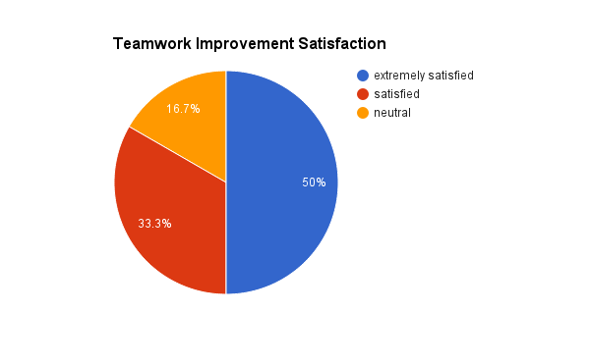
The most common complaint was the late uniform arrival and the lack of organization. Parents felt that the initial meeting provided little information and that they would have preferred the teams to be assigned sooner rather than later.
Recommendations
As stated in the data analysis, the most common problem is organization and lack of volunteers. Once the organization of the program is under control, the rest will fall into place. Getting a sufficient number of volunteers at the beginning of the season would help immensely. There are currently no incentives or training offered to parents who volunteer their time. Fee waivers for parent coaches would be an ideal and inexpensive way to compensate parents for their time. We believe parents would be more willing to coach if they were “paid,” as stated by multiple parents during the interviews. An ideal way to provide coaches and offer an opportunity for community service is to recruit high school students and soccer players to ref the games. Using student volunteers decreases the need for parent volunteers, reduces any incentive costs, and offers a venue for high schoolers to meet their community service hour requirements for graduation.
Another factor that would open the door for many parents is offering some training, this does not require extensive knowledge, but some basic skills and exercises. There are multiple inexpensive ways training could be offered. The delivery method that we believe would be highly effective is providing a “playbook,” which offers lists of basic skills for and “how to’s”, accompanied by resources which offer additional instruction, if needed. The book would also include a variety of activities for different age groups so that the coach has enough material to keep the kids occupied and practicing appropriate skills during the practices. Lastly, it would include plays, both beginning and more advanced, to use in the games. Offering this type of tool would eliminate the having coaches who do not know what to do, but it would also encourage those who do not volunteer due to lack of knowledge, to volunteer.
One of the major problems that was noted by parents was the uniforms arriving so late in the season. Increasing the number of parent volunteers could offer help in this area. There is an enormous amount of work that goes into the organization of the sports programs and having only two employees makes it difficult to get everything done. Recruiting volunteer help off the field is a great opportunity for parents who want to help but are not confident enough in the game of soccer to want to coach. Also, finding a company that has a faster turn-around time for the uniforms is an option. Assigning teams or offering sign-ups for specific teams would also benefit the program, allowing parents to plan according to their schedules.
Participants seemed to attend practice fairly consistently, but a set of consistent general rules would continue to encourage the team mentality of the sport and teach the children the concept of being a team player. As in most competitive sports, those who do not attend practice are given limited to not time on the field for the following game, yet they are expected to attend the game and support their teammates. This is a crucial part of learning team sports and working effectively working with teammates on the field.
There are many other factors that are affecting the efficiency of the program. We believe that as the program begins to run more smoothly, participation will increase and these issues will begin to work themselves out.
Reflection
From the beginning, this seemed like a simple needs analysis. Rachel presented a department that she was familiar and knew could benefit from our research findings. We enjoyed creating the data collection tools. It really made us sit down and think which method would yield the most and most truthful responses. We knew that it was paramount to receive a good amount of responses for us to be able to find if there were any gaps to be filled. With the department being as small as it is, I do believe that our number of participants and responses was enough for this study.
There definitely was a challenge when it came to conducting the interviews. It was very hard to set up a time with the parents and the department head. The parent interview questions and questionnaire ended up being emailed. This was also the case with the department head. She unfortunately did not have time for a face to face interview and also answered her interview questions via email. It definitely is more convenient but a problem that can arise is that an interview in email is obviously not personal. When you sit down to interview someone, not only do you go off of what information they are verbally giving you but you are also able to pick up on any nonverbal clues. The nonverbal clues help you decide what to ask next. There are always follow up questions to ask and more than not, the interviewee usually answers with more than is asked. In email, they may limit themselves to only answering what is asked. If we were to do the project again, we would definitely like to be able to sit down with all of our participants or perhaps even set up a focus group where the parents may feel more comfortable and inclined to speak up about things that were bothering them throughout the season.
It became a tad tricky when it was time to analyze the data. Qualitative data, in our opinion, is always more difficult to analyze. Instead of focusing on only numbers, we have to go through and read each response carefully and then create a category for matching responses. The legend below was used for the parent interviews:

Equipment | E
Training for coaches | T
Participation | P
Organization | O
Volunteer | V
Competition | C

Lessons were learned from this needs assessment. Sometimes we can be biased in our observations and therefore assume there are more performance gaps than what will actually show up in results. Perhaps next time we will choose a company or department that neither of us associate with. We would also set up the interviews earlier. By the time we had chosen our company to use, it was hard to get times to meet with parents and the department head. Next time we will contact our participants sooner.
The takeaway from this needs assessment is that a needs assessment can be conducted on virtually any department, office, or business with relatively few expenses. There does not need to be a great budget set. The department head mentioned that the department did not have the funding for the training her employees needed. A possible way to have the training without spending a large amount of money is to keep the training in-house. The performance gaps have already been identified and the recommendations have been made. A copy of our findings would allow the training to take place without going over the budget. As long as the correct steps are followed, performance gaps can be identified and corrected. Even though we did encounter problems throughout our research, we were ultimately able to set out what we predicted to do and help provide recommendations to improve the department’s performance gap.

Resources
Kristjansson, A. L., Elliot, E., bilger, S., Jones, E., Taliaferro, A.R., & Neal, W. (2015).
Needs assessment of school and community physical activity in rural West
Virginia: The McDowell CHOICES planning effort. BMC Public Health, 15(1),
1-10. doi:10.1186/s12889-015-1702-9
Radhakrishna, R. B. (2007). Tips for developing and testing questionnaires/instruments.
Journals of Extension, 45(1). Retrieved from http://www.joe.org/joe/2007february/tt2.php.
Sleezer, C.M. Russ-Eft, F., & Gupta, K. (2014). A practical guide to needs assessment
(3rd ed.) San Francisco, CA: Wiley. ISBN-13: 978-1118457894

Appendix A
- What is the condition of the equipment?
- Is all the proper equipment provided?
- How many coaches/volunteers are helping with each team?
- How many children are on each team?
- Do the parents appear to be involved?
- Are any rec department employees present?
- Are team moms/dads apparent?

Appendix B
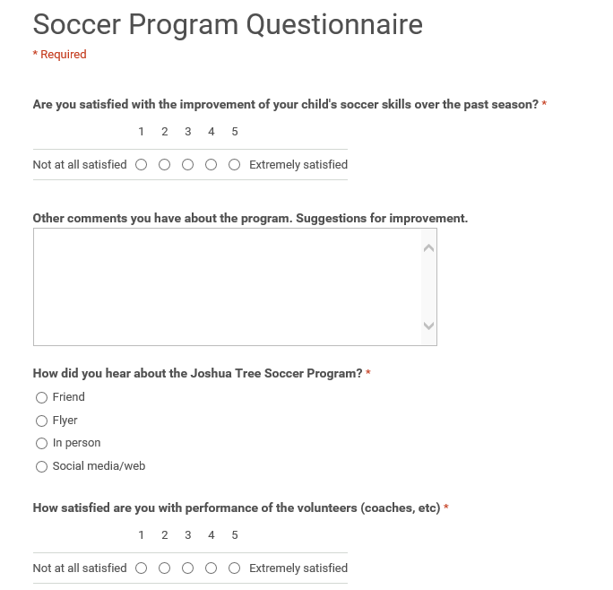
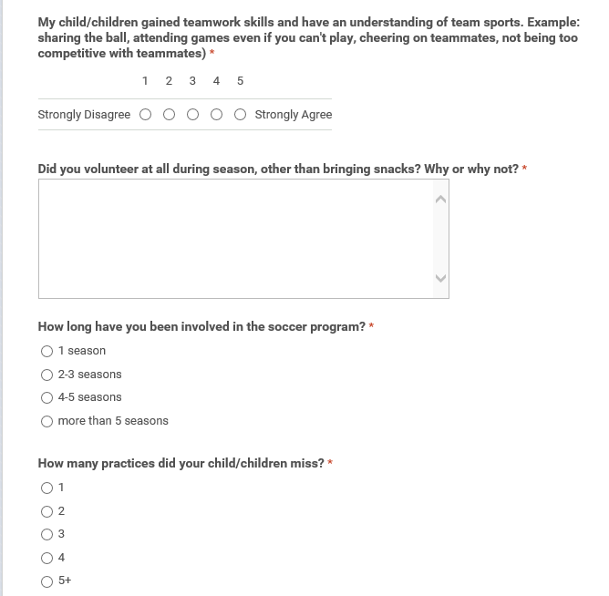
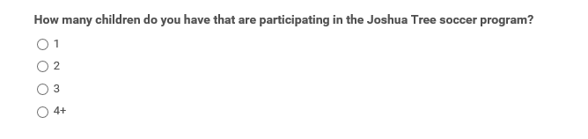

Appendix C
Interview Questions - Rec Department Employee

- How many other employees are there in the Parks & Rec department? What are their duties?
- Are there any other employees that help with the soccer program?
- What is the highest level of education you or your co-workers have achieved?
- How many years of experience do you have working in community sports?
- If you could choose three priority topics for training to focus on, what three would they be?
- Which aspect of training do you feel you or your coworkers are lacking?
- What challenges do you face on a daily basis that you believe can be fixed with training?
- Do you feel weekly, bi monthly, or monthly, strategy meetings would help with any issues?
- How satisfied do you feel parents involved in the program are?
- Describe the connection between community participation and your level of organization.
- Do you feel there is a connection between the number of games won and your staff’s level of organization?
- Describe a tool or a resource that could help your team work more efficiently?
- What would be a barrier that would keep your team from participating in the training?
- How are the fees for the sports used, other than uniforms?
- Is there are particular reason the uniforms came in so late this season? Has this happened in the past?
- Do you think more parent volunteers would help things run more smoothly?
- Other than coaching, what types of volunteering would be helpful?
- Field condition - is there anything that can be done about the lack of grass on the fields, or is it out of your control?

Appendix D
Parent Interview Questions
1. How long have you been involved in Joshua Tree’s soccer program?
2. How many children do you have in the program?
3. Did you attend the information meeting before the season started?
4. Briefly describe how the meeting was organized?
5. Did you feel like there was a significant amount of information given at the meeting?
6. If you have been involved for more than one season, how did this season differ from the others? Better or worse?
7. How do you feel about the instruction given to your children?
8. Do you feel like your children benefited from the program? Why or why not?
9. Did your children learn any new soccer skills?
10. How did you feel about the efficiency of the coach?
11. Do you prefer a “just for fun” program where everyone gets equal playing time or do you prefer a more competitive environment?
12. Have you children expressed any feeling about the soccer program?
13. What would you like to seen done differently or what should stay the same?
14. What types of incentives would encourage you to volunteer?
15. Do you plan on participating in the future? Why or why not? If yes, will you volunteer?

